**CHAPTER-4**

**SYSTEM ANALYSIS**

**4.1 STUDY OF EXISTING SYSTEM.**

Earlier, this kind to process or work was being conducted on paper, where chances of complexity, trust break was more due to human error.

It is possible to have multiple users or task tracker in particular job. To maintain flow of entities, inspection and evidence, everyone will have to manage it manually by maintaining physical documentation of each and every process. Also, it requires more time/effort to manage evidence and inspection, rather than completing the work assign to person. Most of the time it would be very difficult to do paper work if tasks or documents are too large with respect to code, time or complexity.

Hence quite manual, lots of physical paper handling, not reusable to audience.

**4.2 LIMITATIONS OF EXISTING SYSTEM.**

Limitation of existing system is manual work done by the persons to manage all important documents. If documents lost, then recovery is also not possible, there is no such system which maintains the evidence that provide exact proof for specific actions require to complete Job/Task.

**4.3 REQUIREMENTS OF PROPSED SYSTEM**

**4.3.1 Functional Requirements:**

The project shall include all the aspects regarding to the job portfolio which contains job creation, job sharing, job task management, assets managements, job directives, job media management, agent assignment.

**Requirement 1: Registration**

* Name
* Email (Verification required)
* Contact number (Optional verification)
* Password, Confirm Password

**Requirement 2: Login**

* Login using Facebook or Google.
* Login by entering email address and password.

**Requirement 3: Profile Update**

* Edit user details
* Upload Profile picture

**Requirement 4: Job creation**

* Job details
* Add agents (Viewer, Activator, Contributor)
* Manage assets
* Add task
* Create/Add checklist

**Requirement 5: Form creation (Dynamic Form Builder)**

* Create basic form for task
* Create Overview form
* Create Conclusion form

**Requirement 6: Report Generation**

* Generate report that provides summery of the Job.
* Select formatting options for more general describing view of report.

**Requirement 7: Document and contact management**

* List of all the documents uploaded for the specific Job with require details.
* Stores all the registered contacts.
* Able to create document report same as Job report generation.

**4.3.2 Non-Functional Requirements**

* **User Interfaces**

Application will be accessed through a Browser Interface of any device.

* **Hardware Interfaces**

**Developer Side:**

* Operating System: Windows 10
* Processor: Intel i3, 2.4 GHz processor.
* RAM: 16 GB
* Hard Drive: 500 GB

**Client side:**

* Any device which support internet connectivity.
* **Software Interfaces**
* Client side: Web browser.
* Developer side: Web browser, Windows 10, Visual studio 17/Visual studio code.
* **Communication Interfaces**
* The Customer must Connect to the Internet to access the Website:
* Front End – Bootstrap with html and angular 6.
* Back End — PostgreSQL

**4.4 SYSTEM WORK FLOW**

**1) Project flow**

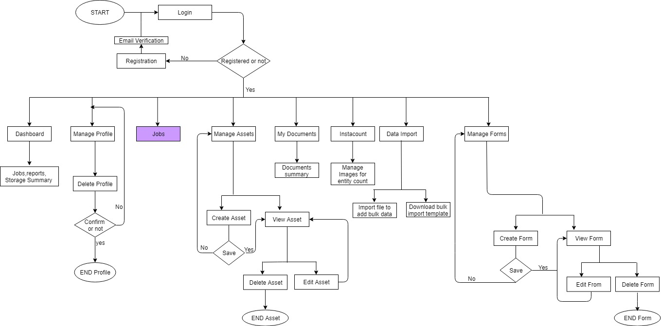

Fig: 4.1 System work flow

**2) Job Module flow**

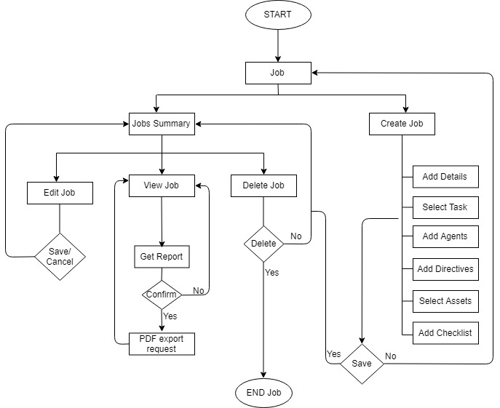

Fig: 4.2 Work flow for job module

**4.5 CLASS DIAGRAM**

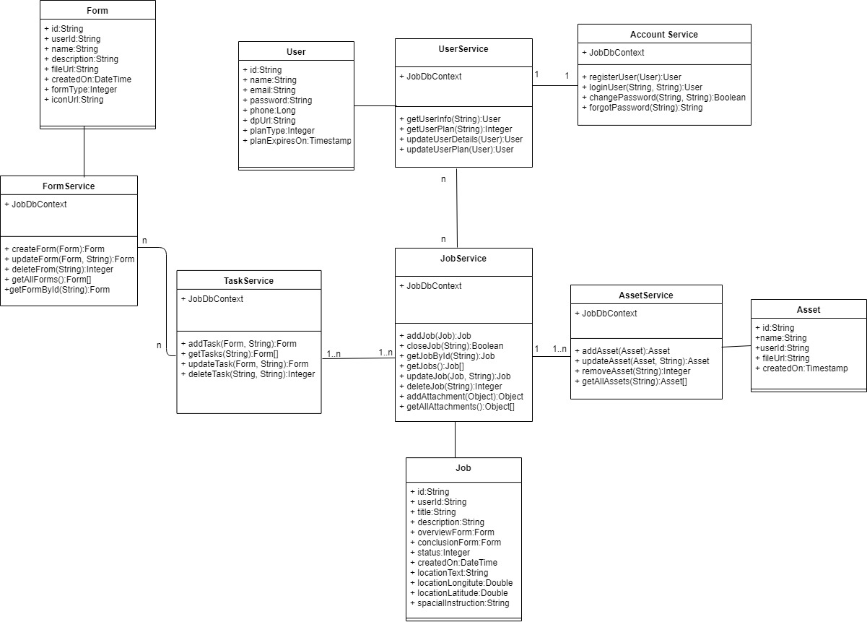

Fig: 4.3 Class Diagram

**4.6 ACTIVITY DIAGRAM**

**1) Activity diagram for Job Module**

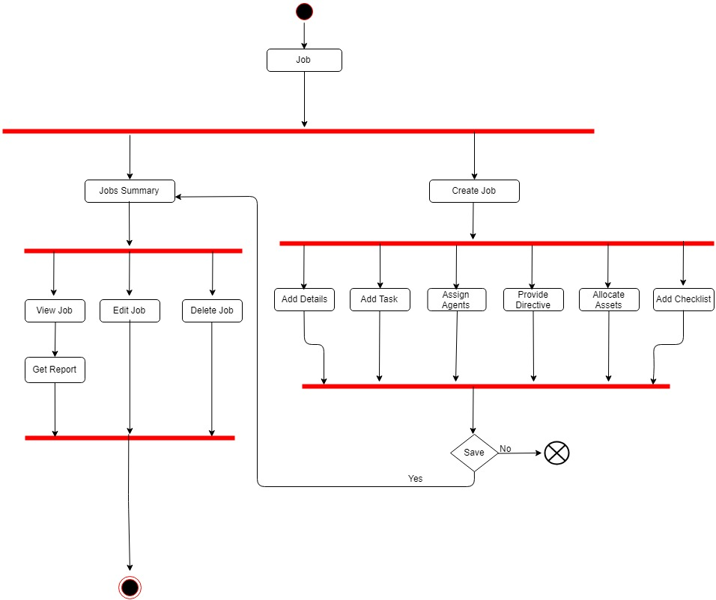

Fig: 4.4 Activity diagram for job module

**4.7 SEQUENCE DIAGRAM**

**1) Sequence diagram for Create Job**

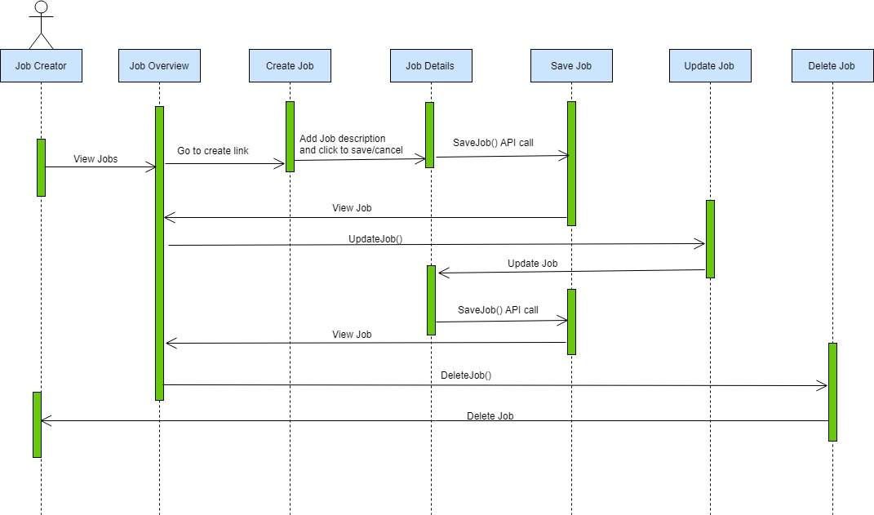

Fig: 4.5 Sequence diagram for Create Job

**2) Sequence diagram for Job Overview**

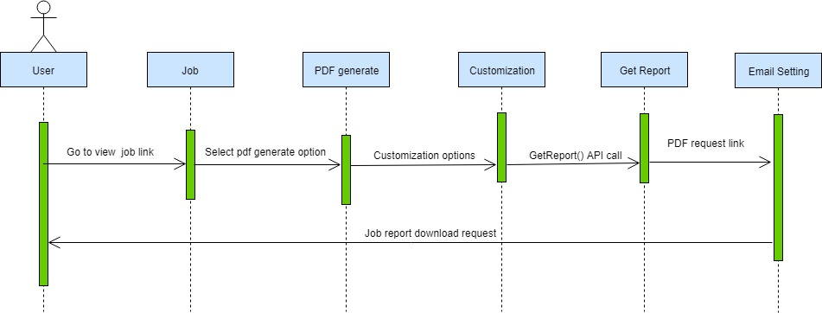

Fig: 4. 6 Sequence diagram for Job Overview

**4.8 STATE CHART DIAGRAM**

**1) State Chart Diagram for Create Job**

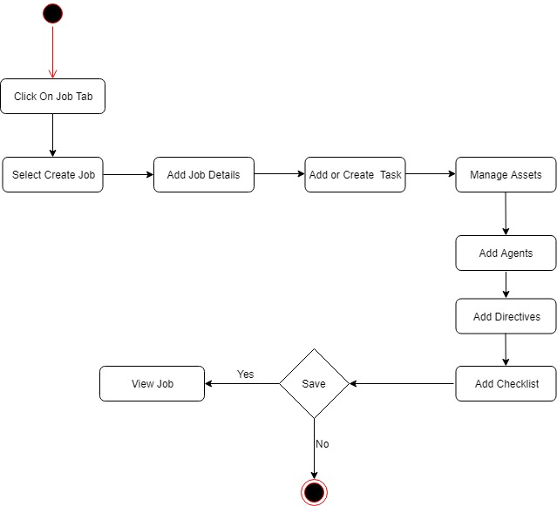

Fig: 4.7 State Chart Diagram for Create Job

**2) State Chart Diagram for View Job**

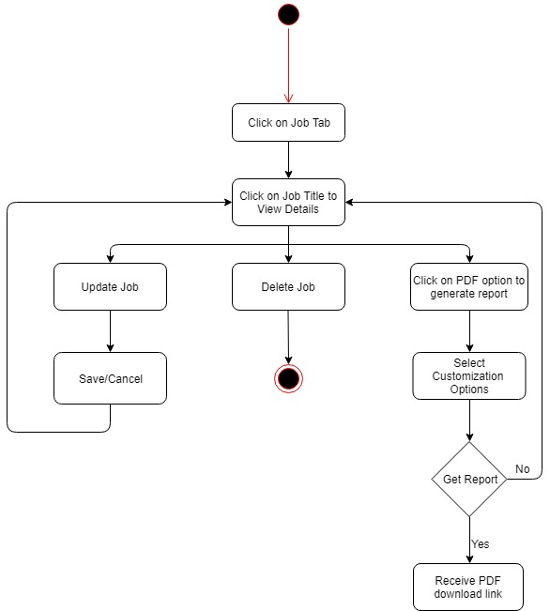

Fig: 4.8 State Chart Diagram for View Job